**Lab 2: DML Statements**

Consider a database defined by following ER Diagram

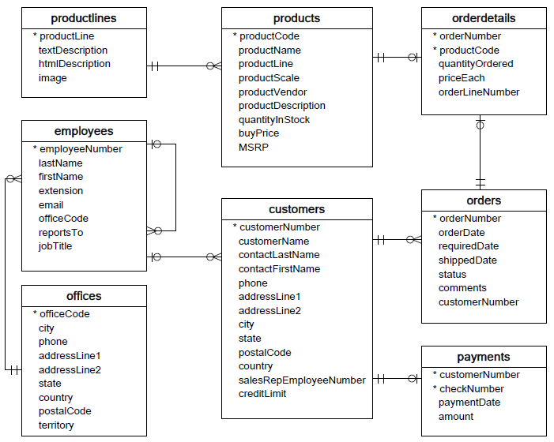

**Import the database file classicmodels.sql and practice following queries:**

**Select Query**

Select * from customers;

**Order By Clause**

SELECT

    contactLastname,

    contactFirstname

FROM

    customers

ORDER BY

    contactLastname;

SELECT

    contactLastname,

    contactFirstname

FROM

    customers

ORDER BY

    contactLastname DESC;

Using MySQL ORDER BY clause to sort values in multiple columns

SELECT

    contactLastname,

    contactFirstname

FROM

    customers

ORDER BY

    contactLastname DESC,

    contactFirstname ASC;

### Using MySQL ORDER BY to sort a result set by an expression

SELECT

    orderNumber,

    orderlinenumber,

    quantityOrdered * priceEach

FROM

    orderdetails

ORDER BY

   quantityOrdered * priceEach DESC;

OR,

SELECT

    orderNumber,

    orderLineNumber,

    quantityOrdered * priceEach AS subtotal

FROM

    orderdetails

ORDER BY subtotal DESC;

## Using MySQL ORDER BY to sort data using a custom list using field()

Suppose that you want to sort the sales orders based on their statuses in the following order:

* In Process
* On Hold
* Canceled
* Resolved
* Disputed
* Shipped

SELECT

    orderNumber,

    status

FROM

    orders

ORDER BY

    FIELD(status,

        'In Process',

        'On Hold',

        'Cancelled',

        'Resolved',

        'Disputed',

        'Shipped');

Using Where Clause

SELECT

    lastname,

    firstname,

    jobtitle

FROM

    employees

WHERE

    jobtitle = 'Sales Rep';

**Where Clause with AND**

SELECT

    lastname,

    firstname,

    jobtitle,

    officeCode

FROM

    employees

WHERE

    jobtitle = 'Sales Rep' AND

    officeCode = 1;

**Where Clause with OR**

SELECT

    lastName,

    firstName,

    jobTitle,

    officeCode

FROM

    employees

WHERE

    jobtitle = 'Sales Rep' OR

    officeCode = 1

ORDER BY

    officeCode ,

    jobTitle;

**Where Clause with Between**

SELECT

    firstName,

    lastName,

    officeCode

FROM

    employees

WHERE

    officeCode BETWEEN 1 AND 3

ORDER BY officeCode;

SELECT

    productCode,

    productName,

    buyPrice

FROM

    products

WHERE

    buyPrice BETWEEN 90 AND 100;

SELECT

    productCode,

    productName,

    buyPrice

FROM

    products

WHERE

    buyPrice NOT BETWEEN 20 AND 100;

**Where Clause with LIKE**

SELECT

    firstName,

    lastName

FROM

    employees

WHERE

    lastName LIKE '%son'

ORDER BY firstName;

SELECT

    employeeNumber,

    lastName,

    firstName

FROM

    employees

WHERE

    lastname LIKE '%on%';

SELECT

    employeeNumber,

    lastName,

    firstName

FROM

    employees

WHERE

    firstname LIKE 'T_m';

SELECT

    employeeNumber,

    lastName,

    firstName

FROM

    employees

WHERE

    lastName NOT LIKE 'B%';

SELECT

    productCode,

    productName

FROM

    products

WHERE

    productCode LIKE '%\_20%' [here \ is used as escape sequence character to address _20]

**Where Clause with IN**

SELECT

    firstName,

    lastName,

    officeCode

FROM

    employees

WHERE

    officeCode IN (1 , 2, 3)

ORDER BY

    officeCode;

SELECT

    officeCode,

    city,

    phone,

    country

FROM

    offices

WHERE

    country IN ('USA' , 'France');

SELECT

    officeCode,

    city,

    phone

FROM

    offices

WHERE

    country NOT IN ('USA' , 'France');

**Where Clause with IS NULL**

SELECT

    lastName,

    firstName,

    reportsTo

FROM

    employees

WHERE

    reportsTo IS NULL;

**Where Clause with Comparison Operators**

SELECT

    lastname,

    firstname,

    jobtitle

FROM

    employees

WHERE

    jobtitle <> 'Sales Rep';

SELECT

    lastname,

    firstname,

    officeCode

FROM

    employees

WHERE

    officecode > 5;

SELECT

    lastname,

    firstname,

    officeCode

FROM

    employees

WHERE

    officecode <= 4;

### Using MySQL LIMIT to get the highest or lowest rows (useful for pagination)

SELECT

    customerNumber,

    customerName,

    creditLimit

FROM

    customers

ORDER BY creditLimit DESC

LIMIT 5;

SELECT

    customerNumber,

    customerName,

    creditLimit

FROM

    customers

ORDER BY creditLimit

LIMIT 5;

SELECT

    customerNumber,

    customerName

FROM

    customers

ORDER BY customerName

LIMIT 10;

## MySQL alias for tables

SELECT

    e.firstName,

    e.lastName

FROM

    employees e

ORDER BY e.firstName;